**GLA UNIVERSITY**

# Institute of Engineering & Technology



Life Style Store

Mid-Term Report

### By

Rohit kumar yadav(191599016)

Km. Sonam(191599018)

Khushboo(191599007)

***Supervised By***

**Mr. Akash Kumar Choudhary**

*(****Asst. Professor****)*

## Department of Computer Engineering & Applications

### DECLARATION

We certify that the work contained in this report is original and has been done by us under the guidance of my supervisor(s).

1. The work has not been submitted to any other Institute for any degree or diploma.
2. We have followed the guidelines provided by the Institute in preparing the report.
3. We have conformed to the norms and guidelines given in the Ethical Code of Conduct of the Institute.
4. Whenever we have used materials (data, theoretical analysis, figures, and text) from other sources, we have given due credit to them by citing them in the text of the report and giving their details in the references.

Name and Signature of Project Team Members:

|  |  |  |  |
| --- | --- | --- | --- |
| **Sr.**  **No.** | **University No.** | **Name of students** | **Signature of**  **students** |
| 1. | 191599016 | Rohit kumar yadav |  |
| 2. | 191599018 | Km. Sonam |  |
| 3. | 191599007 | Khushboo |  |

### GLA University, MATHURA

**CERTIFICATE**

Certified that the project report entitled, “**Life Style Store**

” is a bonafide work done under my guidance by **Rohit kumar yadav, Km. Sonam, Khushboo.**

Date: / / Sign. Of Mentor

**LIST OF FIGURES ACKNOWLEDGEMENT**

We have immense pleasure in expressing our sincerest and deepest sense of gratitude towards our Mentor **Mr. Akash Kumar Chaudhary** for the assistance, valuable guidance and co- operation in carrying out this Project successfully. We have developed this project with the help of Faculty members of our institute and we are extremely grateful to all of them. We also take this opportunity to thank Head of the Department Prof. Shailendra Kumar Mishra, and Dean of Chameli Devi Group of Institutions, Dr. K.S. Jairaj , for providing the required facilities in completing this project. We are greatly thankful to our parents, friends and faculty members for their motivation, guidance and help whenever needed.

Name and signature of team Members:

1. Rohit kumar yadav …………………………………………………………….

2. Km. Sonam …………………………………………………………….

3. Khushboo …………………………………………………………….

|  |  |
| --- | --- |
| CONTENTS | Page No. |
| Title Page | I |
| Declaration | II |
| Certificate by the Supervisor | III |
| Acknowledgement | IV |
| Chapter-1 |  |
| Introduction of the Project Life Style Store | 1 |
| 1.1. Abstract of the Project……………………………………………………………...... | 2 |
| 1.2 Scope of the Project…………………………………………………………………...  ... | 3 |
| 1.3 Reports of the E- Learning………………………………………………………...... | 4 |
| 1.4 Modules of the E- Learning………………………………………………………...... | 4 |
| 1.5  Objective…………………….…………………………………………  …………………...... | 6 |
| Chapter-2 |  |
| Requirement Engineering | 7 |
| 2.1 Software Requirement Specification  …………………………………………… | 7 |
| 2.2 Requirements of the Project………………………………..…………………...... | 7 |
| Chapter-3 |  |
| Analysis & Design | 8 |
| 3.1 System Design of E-learning  …………………………………………… | 8 |
| 3.2 General task involved in the design process  ……………………………...... | 8 |
| 3.3 Project Category………………………..………………………………………  …………. | 9 |
| 3.4 Project Planning…………………………………………………………………  …………. | 10 |
| 3.5 Steps for successful software project………………………………………….. | 11 |

Introduction

**Chapter-1**

**Introduction**

**1.1 Introduction**

As the world is going is going digital it’s a necessity now days to bring business online. We developed and e-commerce website to sell all daily essentials. Also an Handy craft website which can sell all handmade articles from food to clothes. Technology used in these two websites was HTML, CSS, BOOTSTRAP, JAVASCRIPT for the front end and for back end PHP was used.

Some functionalities were:

* Add to cart
* Wishlist product
* Quick view
* Search products
* Pay online/ COD

For developing Handy craft website I used JOOMLA which is free open source content management system (CMS) for publishing web content.

**1.2 Objectives**

The objective was to develop an e-commerce website which can sell all the daily essentials. Also, making UI easy to that both user and seller can easily use it.

**1.2.1 To save the time and resources**

You just need to sign up once and you are done order all groceries and daily essential by just clicking few buttons and get it delivered at your doorstep.

**1.2.2 To reduce the work load**

As people now days are busy in their own works, it will help them save some time for themselves and they can spend it with something they love to do.

**1.2.3 To make it easy to search any order**

It will be much easier to find right thing for one as he/she can easily search and order things they want saving a lot of time.

**1.2.4 To make the website user friendly**

The website was developed keeping in mind for all types of people so that each and every one can use it with ease.

**1.3 Motivation**

In desktop base website creating system is easy to understand. Since I accept Internship it seems to me I am beginner and primary level to learn web development, so it is easy and interesting to learn and create. Also technologies used are interesting and easy to build a project by fully PHP, HTML, CSS, MYSQL, BOOTSTRAP.

**Functionalities provided by E-learning Management System:**

* Home Page Product Display
* Registration Page
* Login Page
* Add to Cart
* Setting Page

# COMPONENTS OF THE PROJECTS

## How to Login

In this module, the user will enter his username and password to view and buy latest products. There will be 2 types of users Administrator/Customer

## How to be a member of this application

In this site, the candidate can join this application , if he is not a member yet by pressing sign up link .User should provide some details that are asked to join.

## How to view the model details

Any cloth can be searched by selecting the model no. which the user wish to view or buy.

## How to give order

First the user has to login,and then he will visit the view products page. There he will select the cloth he wants to buy and then he will click on show products detail .There he can purchase that cloth.

## How to pay money

The user can pay through debit or credit cards.

# Modules

* 1. **Login Module** –In this module user can enter the application by providing username and password and start shopping.
  2. **Admin Module** – Admin can add, modify and delete the latest varities of clothes.
  3. **Join Module** – In this module user can become a part of the site by providing some necessary information for example first name, last name, password, confirm password, email and other details.
  4. **Shopping Module** – The customer can view and buy latest varities of clothes.
  5. **Administrator** – Can add, modify, and delete the cloth details.

Focused Modules:

* **Registration:-**

In this, first the interested students get registered by selecting their desired username and password and by providing the necessary details.

Then each user profile will be maintained which can be edited by the user when desired. Each person will register only one time. Details of each person along with their username and password is saved permanently in the database.

* Login:-

After providing the correct username and password, the user log’s in to the homepage. There the user can select the available subjects to further learn about them. If user enter wrong username or password then they block their account temporary and after some security verification they will able to access their account.

* 1. Objective

The objective of this page is to develop a general purpose E- Commerce store where product like cloths can be bought from the comfort of the home through the internet. However for the implementation purposes, this paper will deal with an online shopping for cloths. An store is an virtual store on the internet where costumer can browse the catalog and select products of interest. The selected items may be collected in shopping cart. At checkout time, the item in the shopping cart will be presented as an order. At the time more information will be needed to complete the transaction. Usually, the costumer will be asked to fill or select a billing address, as shopping address ,a shopping option and payment information such as card number. An Email notification is sent to the costumer as soon as the order is placed.

### Some Snapshots of the project Index Page:

### 

### 

### product Page:

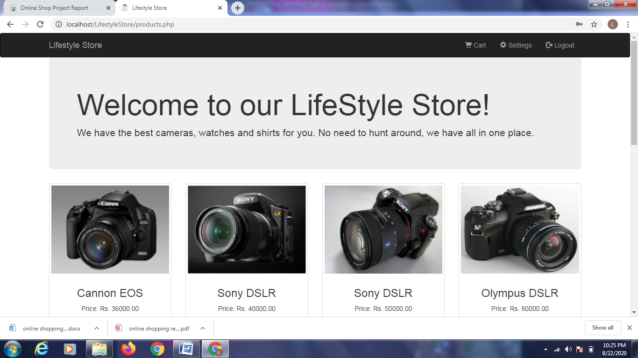

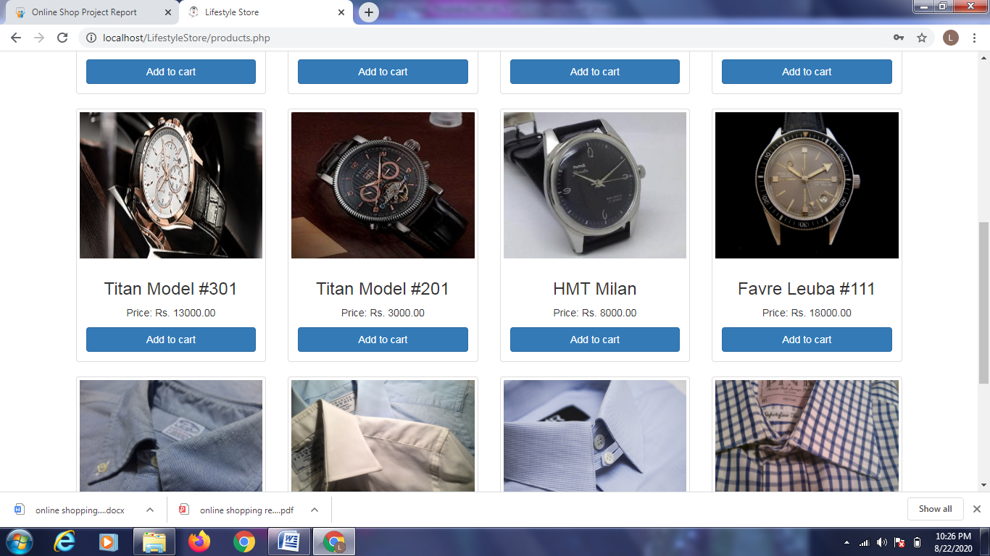

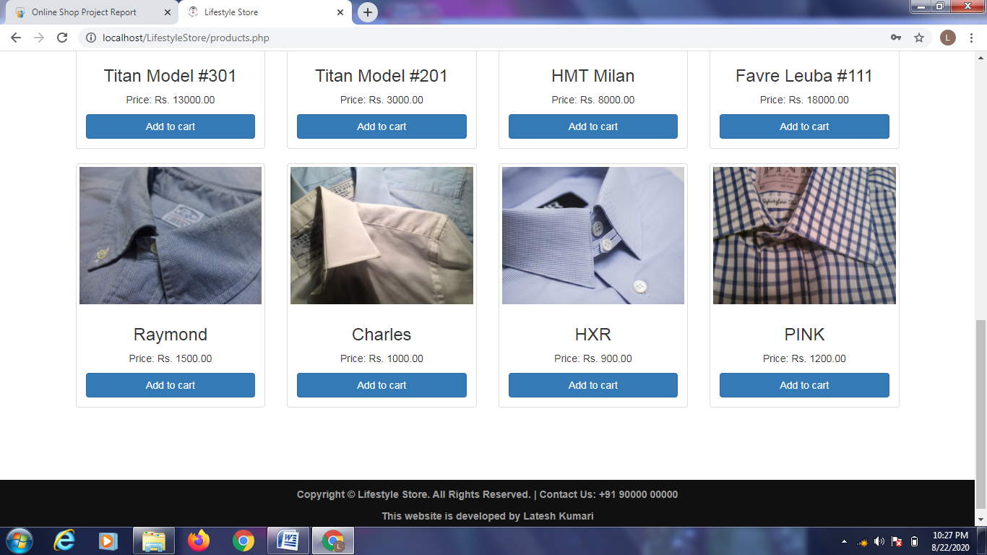

**Registration page:-**

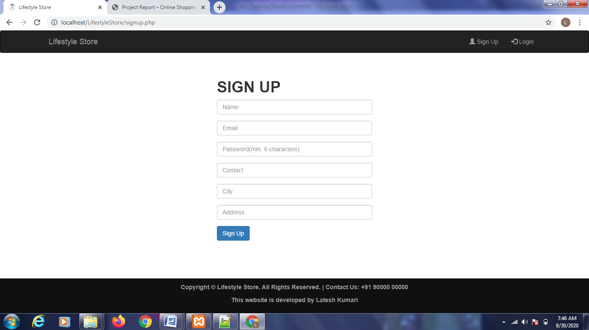

Login Page:-

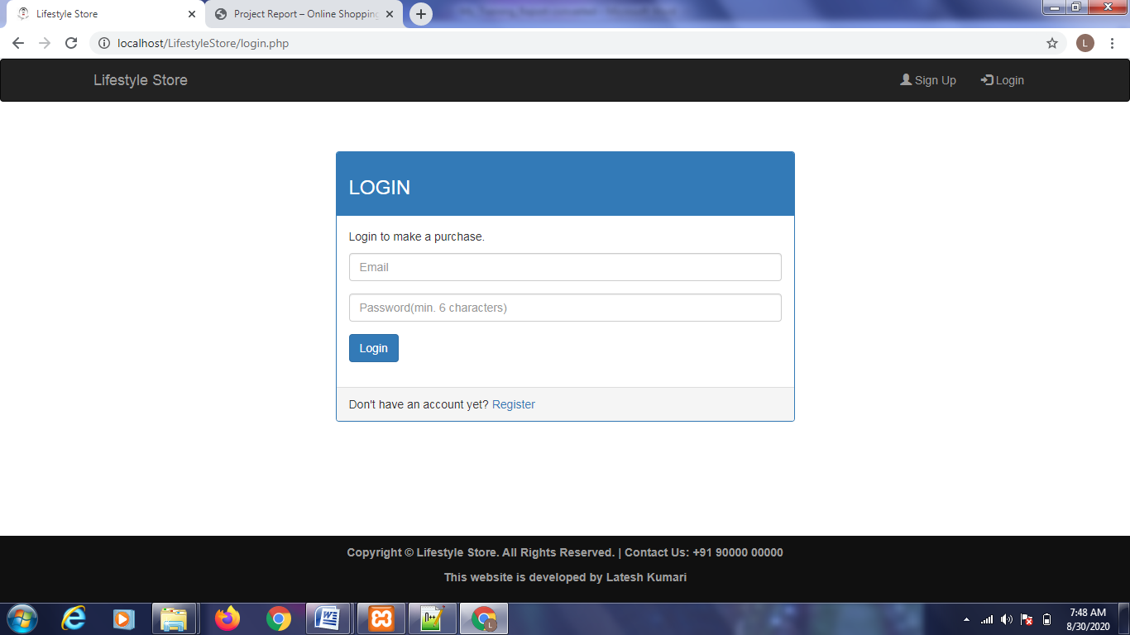

Add To Cart page:-

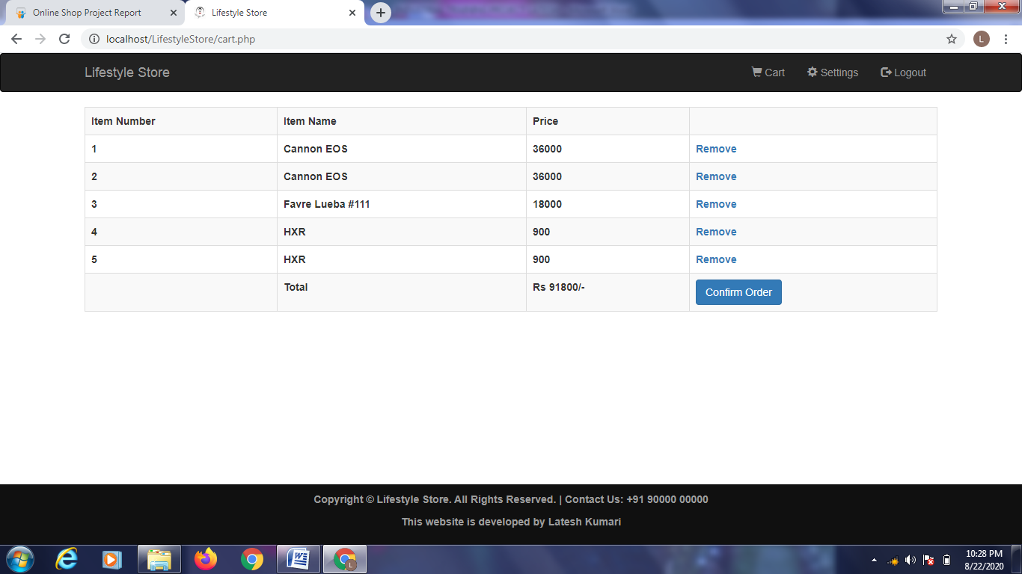

Setting page:-

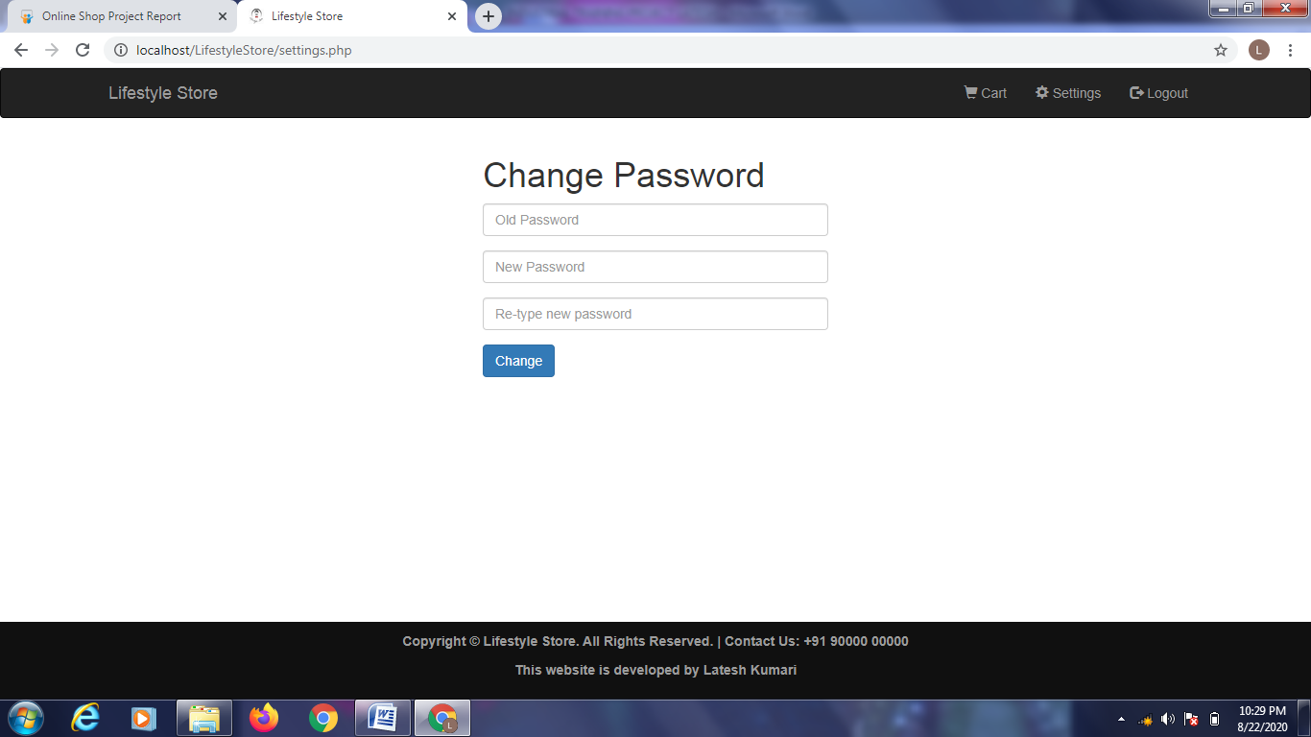

Success page:-

